**Oracle 18c to 19c Data Guard Upgrade**

During oracle data guard upgrade, the standby database(s) can be upgraded implicitly via the redo from the primary database, and there is no need to rebuild the [**standby database**](https://www.support.dbagenesis.com/post/oracle-data-guard-best-practices-for-high-availability-and-disaster-recovery) after upgrade.

* [Before Upgrade](https://support.dbagenesis.com/post/oracle-18c-to-19c-data-guard-upgrade#viewer-7n2sa)
* [Upgrade Primary Database](https://support.dbagenesis.com/post/oracle-18c-to-19c-data-guard-upgrade#viewer-3j6ju)
  + [Install Oracle 19c on Primary](https://support.dbagenesis.com/post/oracle-18c-to-19c-data-guard-upgrade#viewer-a06ps)
  + [Start DBUA on Primary](https://support.dbagenesis.com/post/oracle-18c-to-19c-data-guard-upgrade#viewer-797vu)
* [Post Upgrade](https://support.dbagenesis.com/post/oracle-18c-to-19c-data-guard-upgrade#viewer-a44j2)
* [Enable Redo Log Transport and Apply](https://support.dbagenesis.com/post/oracle-18c-to-19c-data-guard-upgrade#viewer-dnhn4)

*Install the new Oracle Home on both primary and standby*

**Before Upgrade**

**Stop Data Guard: On primary database, defer the redo log transport to the standby**

**On Primary:**

**===========**

**SQL> show parameter log_archive_dest_2**

**SQL> alter system set log_archive_dest_state_2='defer' scope=both;**

**Cancel redolog apply on standby and shutdown the database**

**On Standby:**

**===========**

**SQL> alter database recover managed standby database cancel;**

**SQL> Shut immediate;**

**Upgrade Primary Database**

Install the 19c pre-install package on both primary & standby server

**On Primary & Standby:**

**=====================**

**yum install -y oracle-database-preinstall-19c**

**Install Oracle 19c on Primary**

**Unzip the 19c software under 19c home and start the runInstaller**

**cd /u01/app/oracle/product/19.3/db_home**

**unzip LINUX.X64_193000_db_home.zip**

**./runinstaller**

**Purge the RECYCLEBIN and also check the pre-upgrade summary**

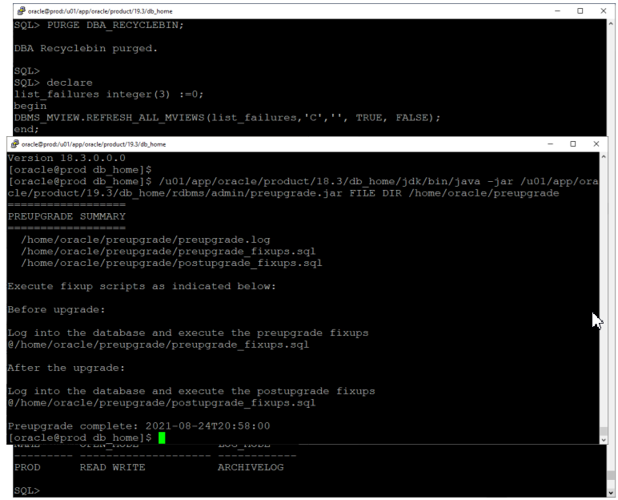



**Create a guaranteed restore point**

**Start DBUA on Primary**

**Post Oracle Data Guard Upgrade**

**Install new home in standby, Update the listener on the standby host. Be sure to update the Oracle Home information in the listener.ora**

**vi $ORACLE_HOME/network/admin/listener.ora**

**lsnrctl reload**

export OLD_HOME=/u01/app/oracle/product/18.3/db_home

export NEW_HOME=/u01/app/oracle/product/19.3/db_home

export ORACLE_HOME=$NEW_HOME

export ORACLE_SID=prod

#Set ORACLE_UNQNAME to DB_UNIQUE_NAME

export ORACLE_UNQNAME=standby

Copy TNS

**#Back up files**

**cp $NEW_HOME/network/admin/tnsnames.ora**

**$NEW_HOME/network/admin/tnsnames.ora.backup**

**#Copy from old to new home**

**cp $OLD_HOME/network/admin/tnsnames.ora $NEW_HOME/network/admin**

**Now, you can edit /etc/oratab and update the information about the Oracle Home to match the new Oracle Home**

**vi /etc/oratab**

**Copy SPFile and password file to the new Oracle Home**

**cp $OLD_HOME/dbs/orapw $ORACLE_SID $ORACLE_HOME/dbs**

**cp $OLD_HOME/dbs/spfile $ORACLE_SID.ora**

**$ORACLE_HOME/dbs**

**Start the database**

**SQL> startup mount**

**Enable Redo Log Transport and Apply**

On the primary database re-enable redo log transport to standby database

**SQL> alter system set log_archive_dest_state_2='enable' scope=both;**

On the standby database restart redo apply

**SQL> alter database recover managed standby database disconnect from session;**

Thank You!!

SOURCE : https://support.dbagenesis.com/post/oracle-18c-to-19c-data-guard-upgrade#viewer-7n2sa